**CAR RENTAL SYSTEM**

**(CARGO)**

### A Project Work

*Submitted in the partial fulfillment for the award of the degree of*

# BACHELOR OF ENGINEERING

# COMPUTER SCIENCE

### IN

### BIG DATA ANALYTICS

### Submitted by:

### Tatikonda Chandrashekharachari

### 20BCS4428

### Under the Supervision of:

### MS MONIKA



# DEPARTMENT OF COMPUTER SCIENCE AND ENGINEERING APEX INSTITUE OF TECHNOLOGY

### CHANDIGARH UNIVERSITY, GHARUAN, MOHALI - 140413,

**PUNJAB**

#### MONTH & YEAR

**DECLARATION**

I, **‘ Ashrith Ravikanti ’**, student of **‘BIG DATA ANALYTICS** , **session:**

**2020-2021** , Department of Computer Science and Engineering, Apex Institute of Technology, Chandigarh University, Punjab, hereby declare that the work presented in this Project Work entitled ‘**Car Rental System’** is the outcome of our own bona fide work and is correct to the best of our knowledge and this work has been undertaken taking care of Engineering Ethics. It contains no material previously published or written by another person nor material which has been accepted for the award of any other degree or diploma of the university or other institute of higher learning, except where due acknowledgment has been made in the text.

|  |  |  |  |
| --- | --- | --- | --- |
| **S.No.** | **Name** | **UID** | **Signature** |
| **1.** | **Chandrashekharachari Tatikonda** | **20BCS4428** |  |

#### Date:

**21/07/2021**

**Place:**

**Chandigarh**

### 

### 

ii

**ABSTRACT**

In today's world, there are online vehicle rental businesses that provide a great deal of value to consumers. This manual system's existence can address the issue of availability and give ease to the customer while renting an automobile. The manual automobile rental method is only available during business hours. As a result, clients have a limited amount of time to complete any purchases or make automobile reservations. Nowadays, the availability of online vehicle rental services has overcome the constraint of business operating hours. Aside from that, some customers have had difficulty selecting a car to hire that meets some of the most crucial conditions.

To meet these demands, the system employs a data matching approach. Users' data will be matched by the system, which will advise or propose an automobile to be hired. However, the user has the option of accepting the advice or viewing the system's automobile catalogue to make their own decision.

This system allows the company to search user information from the database based on their identity card number by retrieving, generating, updating, and deleting data or information based on the security level. C++ will be used to create the system.

**Acknowledgement**

I'd want to offer my deepest appreciation to everyone who contributed to the research for this project; without their active participation, the project's preparation would not have been finished within the deadline.

Ms. Mounika, our esteemed Coordinator, has inspired me to accomplish this assignment with total focus and attention. He aided me in completing this project by providing me with unwavering support and patience throughout the process.

**LIST OF FIGURES**

3.1 User Case Diagram

3.2 Member Registration Diagram

3.3 Can Renting Diagram

3.3 Sequence Diagram For Adding A Car

3.5 View Data Diagram

3.6 Manage Data Diagram

3.7 Data Flow Diagram(Level1)

3.8 Data Flow Diagram(Level 0)

3.9 Class Diagram

# 

# Table of Contents

|  |  |  |
| --- | --- | --- |
|  | Title Page  Declaration of the Student Abstract Acknowledgement  List of Figures | i |
| ii |
| iii |
| iv |
| v |
|  |
|  |
| **1.** | **INTRODUCTION\*** | **1** |
|  | * 1. Problem Definition   2. Project Overview/Specifications* (page-1 and 3)   3. Hardware Specification   4. Software Specification s | 1  2  3  4  4 |
| 1. **LITERATURE SURVEY**    1. Existing System    2. Proposed System    3. Feasibility Study* (page-4) 2. **PROBLEM FORMULATION** | | **5** |
| 5  6  7 |
| 9  16  18  19  22 |
| 1. **OBJECTIVES** 2. **METHODOLOGY** 3. **CONCLUSIONS AND DISCUSSION** 4. **REFERENCES** | |

# INTRODUCTION

The world has evolved into a place of rapid technological advancement, with virtually everything done physically being converted into a digital form. People's activities have been changed into computer-assisted labor in recent years. One of them is the project's core goal, which is the Car Rental System. People used to hire vehicles for personal reasons, which was a system that existed in past years. Many people's plans to travel or relocate from one area to another for business purposes, tours, visits, or holidays necessitate the use of a car, and for these reasons, car rental is quite beneficial

The concept aims for automobile rental businesses to hire out their vehicles to clients. This program aids in the addition and management of automobile data as well as the admin's understanding of the consumers. This initiative aids users in the rental of automobiles.

Cargo: vehicle hire implementation the system will allow corporate personnel to save time and effort. Some information is obtained in this manner. The practicality of obtaining a result, as well as its automation, would outweigh what the human method achieves

.

1. **PROBLEM DEFINITION**

An automobile rental is a vehicle that may be rented for a price and utilized for a specific length of time. Getting a rental automobile makes it easier for people to travel around when they don't have access to their own vehicle or don't own one at all. A person in need of a car must call a rental car business and sign a contract for a vehicle. This method improves client retention while also simplifying vehicle operation.

The growth of information technology and internet usage has considerably improved many business operations and communication between businesses and their consumers, including the automobile rental sector. The following services are included in this E-Car Rental System:

• Improve Business Processes: To be able to leverage internet technology to project the rental company's services to the rest of the globe rather than just their local domain, therefore increasing their return on investment (ROI).

• Online Vehicle Reservation: A feature that allows clients to reserve available automobiles in advance of their scheduled pick-up date or time.

• Customer registration: A registration gateway to save customer information, track transactions, and use the information to provide better and more personalized services.

• Group bookings: Allows customers to reserve space for a group, such as for weddings or business meetings.

1. **PROJECT OVERVIEW**

This project includes a wide variety of topics, from business ideas to computers, and it necessitated the completion of several research in order to achieve the project's objectives. The following topics are covered:

• Vehicle rental sector:

This involves research on how the car rental industry operates, the processes involved, and the opportunities for improvement.

• The C++ programming language was used to build the program e.

• The technology may be used efficiently both by ordinary customers and company personnel.

1. **HARDWARE SPECIFICATIONS**
2. Processor Intel dual core
3. RAM 8GB
4. Monitor 15 inch color
5. HDD Minimum 20 GB
6. Key board Standard 102 keys
7. Mouse 3 buttons
8. **SOFTWARE SPECIFICATIONS**
9. Operating system Windows 10
10. Code Editor Visual Studio Code
11. Environment MINGW
12. Language C++
13. **LITERATURE REVIEW**

The literature review is relevant for the development of the project and mentions the existing alternative systems. Books, articles, journals, and websites are included in the sources.

Many researchers have worked in this area, and they can now propose an anonymous car rental protocol based on NFC technology. The following are some of their key contributions: Anonymity is one of the most important factors to consider. Only a trusted third party (TTP) receives personal information from users.

Car rental companies have no way of knowing who their customers are.

(A) The ability to unlink. By analyzing rental history, car rental companies are unable to establish any link between users' rental records and their identities.

(B) The ability to trace. The rental company can ask TTP to reveal users' identities if there are any consumer disputes or accidents.

**2.1 Existing System:**

Users will be able to hire a car through a car rental service for a set charge. There was no obvious web-based UI to assist people in renting a vehicle before today. They had to hire the car via their workplaces on their own. Managing rental automobiles was a challenging task. It was difficult to keep track of all the rental automobiles.

**2.2 Proposed System:**

The user will be able to rent a vehicle using this tool. The user must first log in to the system and check for automobile availability. The user selects a car type as well as the date and hour of the travel. The system will look up the car's availability and rent it to the customer. The user can make a payment over the internet. The program is written in C++. All information on rental automobiles is recorded in a database. The user must provide his name, address, and phone number, as well as search for available rental vehicles. The user interface is straightforward. The major benefit is that the customer will be able to select a vehicle based on his budget.

**2.3 Feasibility Study:**

Vehicle transactions, such as vehicle details and driver information, are stored in the car rental system. On each transaction, the system aims to manage its vehicle usage. This will simplify the process of recording vehicle booking transactions, listing and sorting their booking transaction reports, providing accurate information such as car availability on a daily basis, and easing the burden of paperwork.

Feasibility is a metric that determines how beneficial and practical an information system will be for a company. A feasibility study examines the viability of an idea, focusing on identifying potential issues and attempting to answer one main question: Will the idea work, and should you pursue it?

While evaluating a project's feasibility, the following criteria can be identified.

**Operational Feasibility:**

This project's main goal is to create a system that is both useful and beneficial to the user/client. All of the system's requirements, as well as those required by the client, are listed below. As a result, this system collects data from the user and generates reports so that the client can keep track of their entire fleet of vehicles, drivers, and booking transactions. This will make the company's and employees' jobs easier. The user's information will be securely stored in a single database and closely monitored. The generated report, as well as the information provided, would be accurate because the system generates reports automatically.

**Technical Feasibility:**

Cargo: vehicle hire implementation the system will allow corporate personnel to save time and effort. Some information is obtained in this manner. The practicality of obtaining a result, as well as its automation, would outweigh what the human method achieves. This project's research would go through the same procedure, hand in hand. The researchers will be able to keep up with the system as it develops. Because the development of the system is based on such factors, verifying the software and hardware conditions should also be a need. Every time, the researchers would improve the system and put all of their knowledge into practice

# PROBLEM FORMULATION

* **User Case Diagram(Car Rental)**

The interaction between the actors and their use cases is described in depth in the actor and use case description. The description allows for a thorough knowledge of how actors interact with the system via use cases.

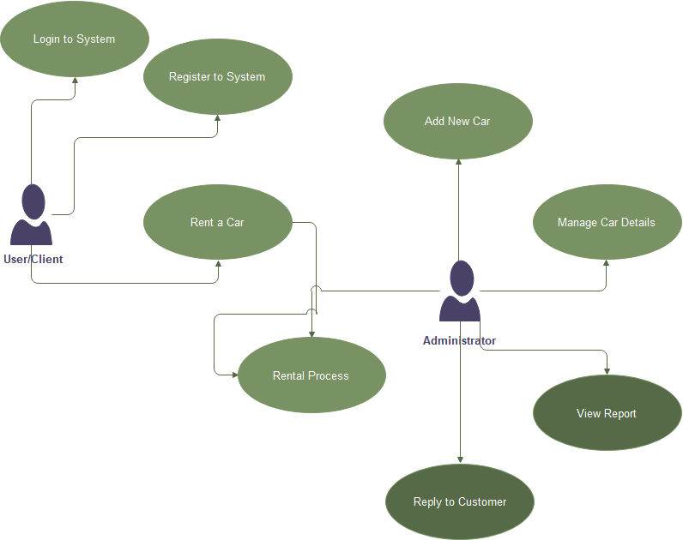

3.1.user case diagram

* **Sequence Diagram**

By describing the objects and the messages they pass, sequence diagrams are used to show the behaviour of objects in a use case. It shows how objects interact over time in a graphical form. In the execution of a use case, sequence diagrams illustrate an actor, the objects and components with which they interact. A single Use Case'scenario' or set of events is represented by a single sequence diagram. Messages move from one object to another in sequence diagrams, which correlate to the methods and events provided by an object.

1. **Member Registration**

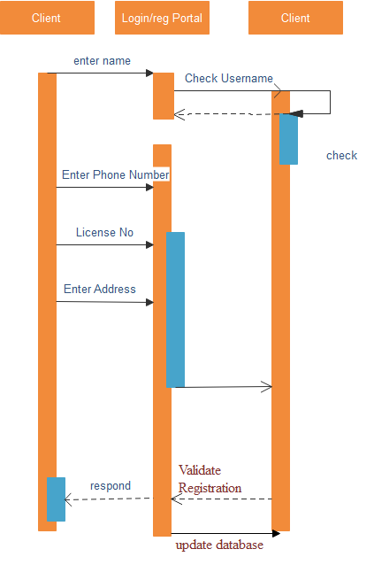

3.2Member registration diagram

1. **Car Renting**

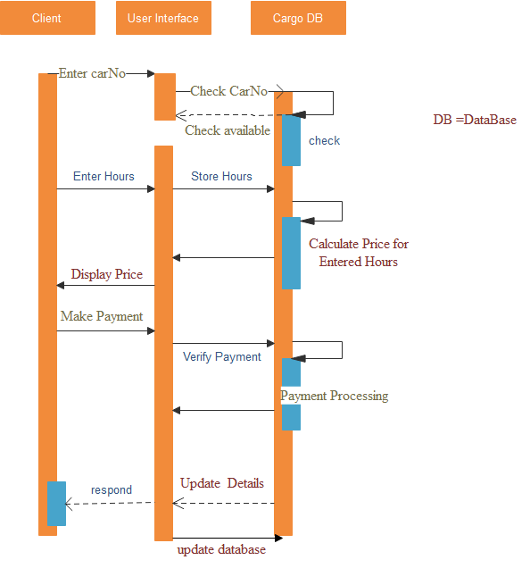

3.3Can renting diagram

1. **Adding Car**

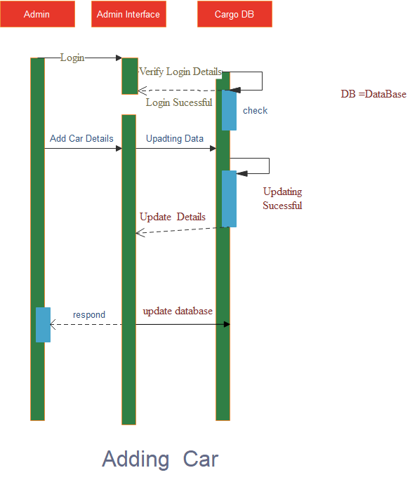

3.4Adding car diagram

1. **View Data**

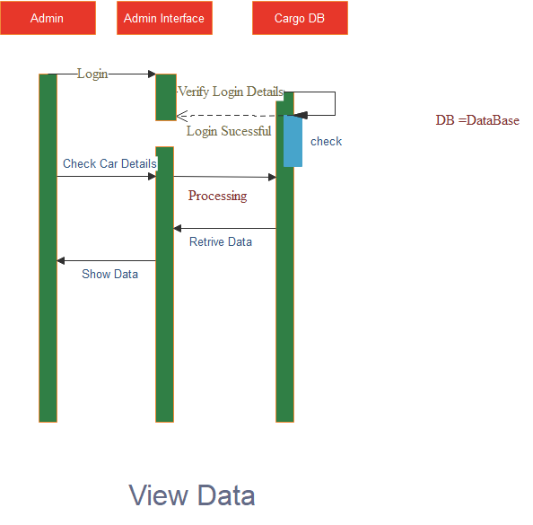

3.5 view data diagram

1. **Manage Data**

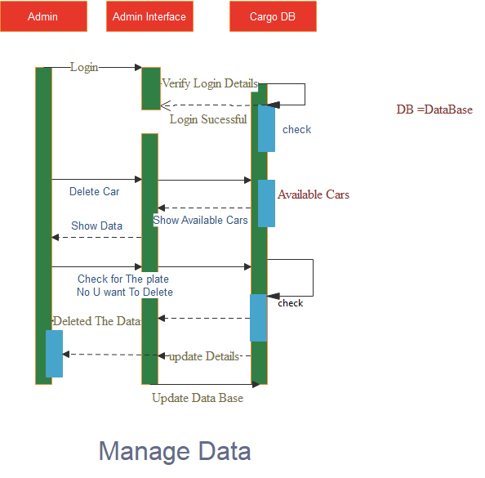

3.6manage data diagram

* **Data Flow Diagrams**

A Data Flow Diagram (DFD) is a graphical representation that depicts the information flow and the transforms that are applied as data moves from input to output.

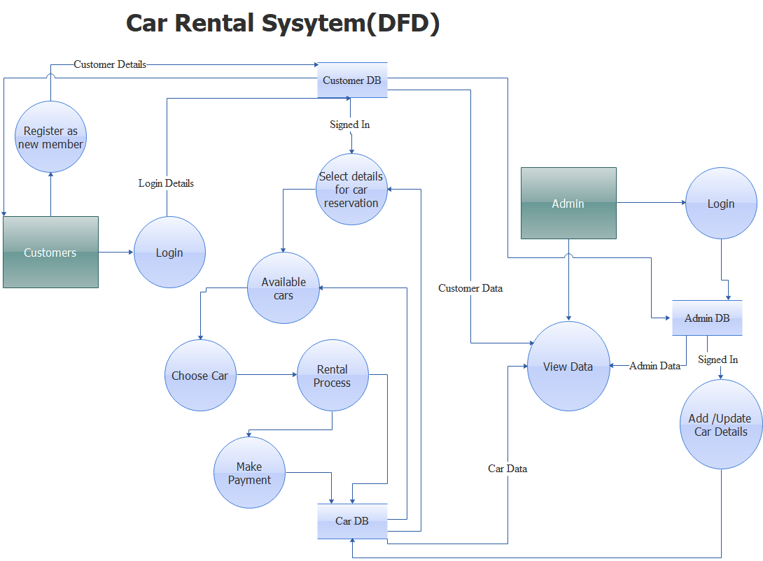

3.7 DATA FLOW DIAGRAM(LEVEL1)

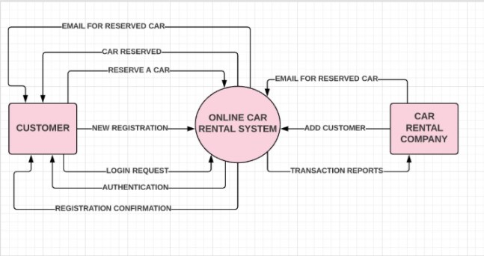

3.8 DATA FLOW DIAGRAM(LEVEL 0)

* **Class Diagram**

The class diagram is the fundamental building element; in a class diagram, a number of classes are recognised and organised together, allowing the statically relations between those objects to be determined.

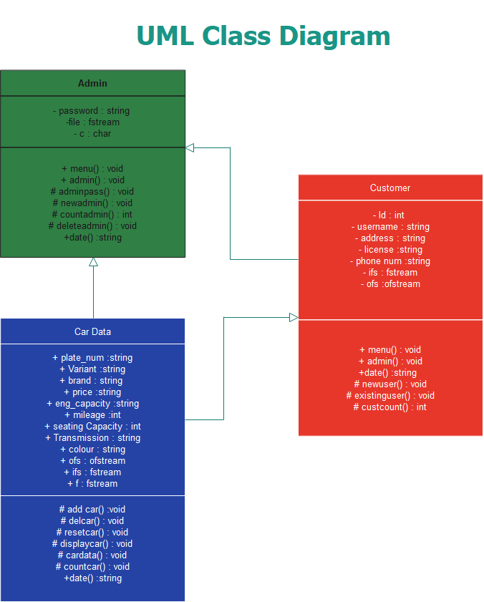

3.9 CLASS DIAGRAM

# RESEARCH OBJECTIVES

The study's primary goal is to develop and execute an automobile rental system for a company.

The study's specific goals are as follows:

1. To provide a simple and secure system that protects clients' information as well as the

organization's private information.

1. To provide a user-friendly system that allows customers to check vehicle availability

and book or reserve a car online.

1. To create a system that allows customers to pay for their automobile rental online.
2. To assist the company, keep track of transactions, build a system that maintains

booking and reservation information, as well as payment history

# METHODOLOGY

Along with business analysis, requirement specification, design, programming, and testing, project management is an important element of the software engineering process. For years, it has been a source of heated dispute. Despite the fact that project management techniques are getting more mature, just approximately half of businesses (53 percent) are fully aware of their value.

Any project, regardless of its magnitude, should follow a set of steps that can be controlled and managed. A typical project management process, according to the Project Management Institute (PMI), contains the following phases:

1. initiation,
2. planning,
3. execution,
4. monitoring/performance.

These phases describe the project management lifecycle and serve as a roadmap for completing certain tasks.

1. **RESULTS AND DISCUSSION**

**OUTPUT :**

**TERMS AND CONDITIONS :**

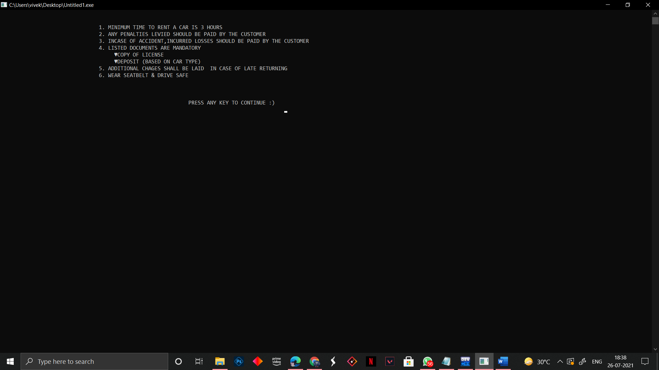

**MAIN MENU :**

1.ADMIN INTERPHASE

2.USER INTERPHASE

3.EXIT

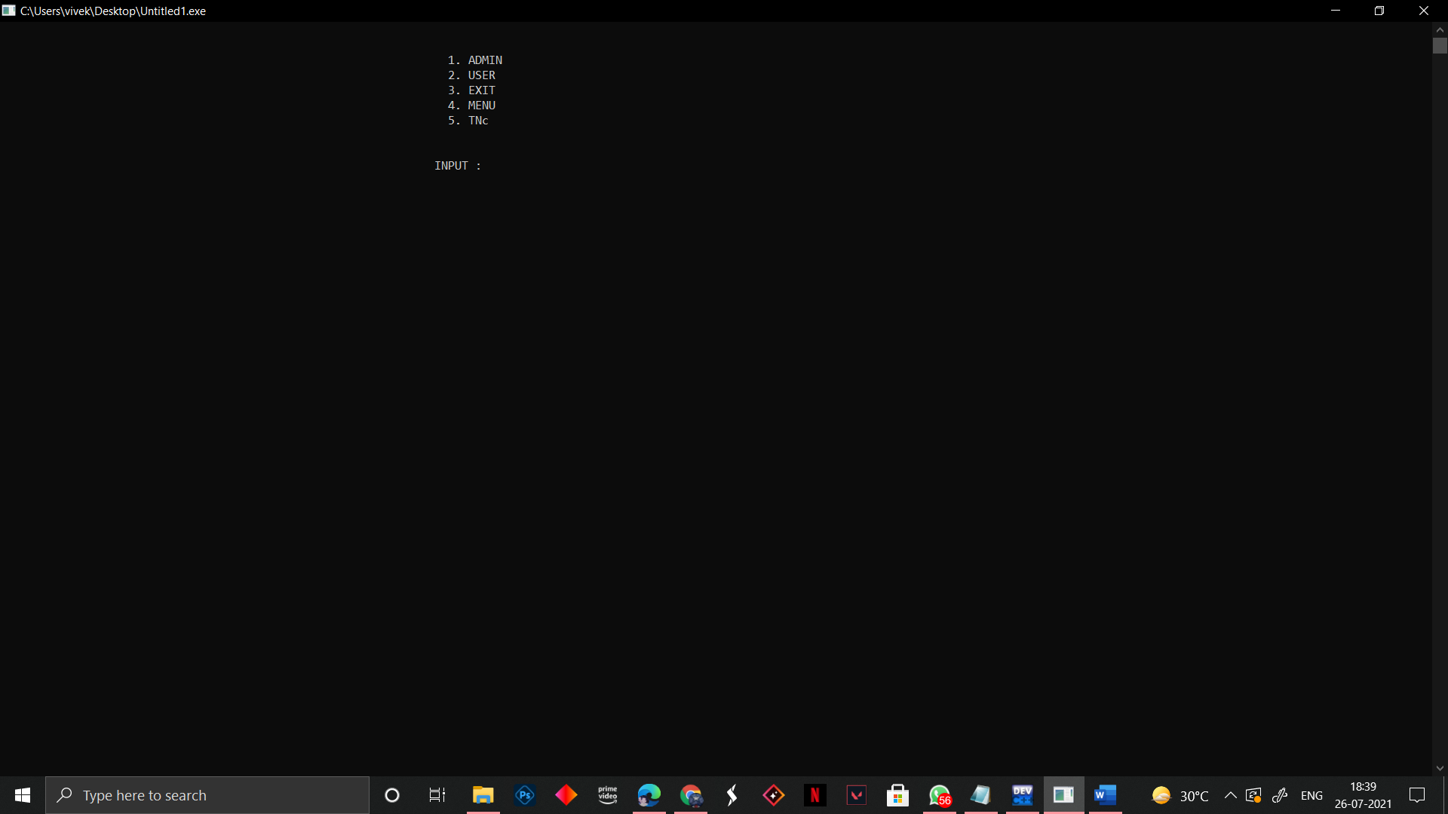

**Admin Interphase :**

So Firstly, The Admin Login into The Admin Interphase Through His Pass Code and Can

1 . Add An Admin

2.Remove an Admin

3.Access to Data

4.Add A Car

5.Delete A Car

6.Can Reset the Car List

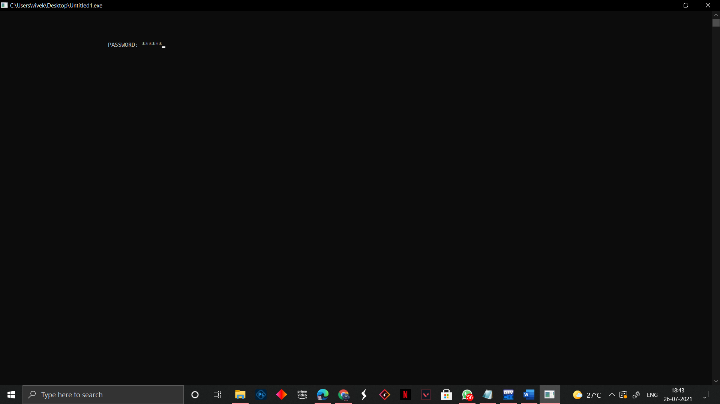

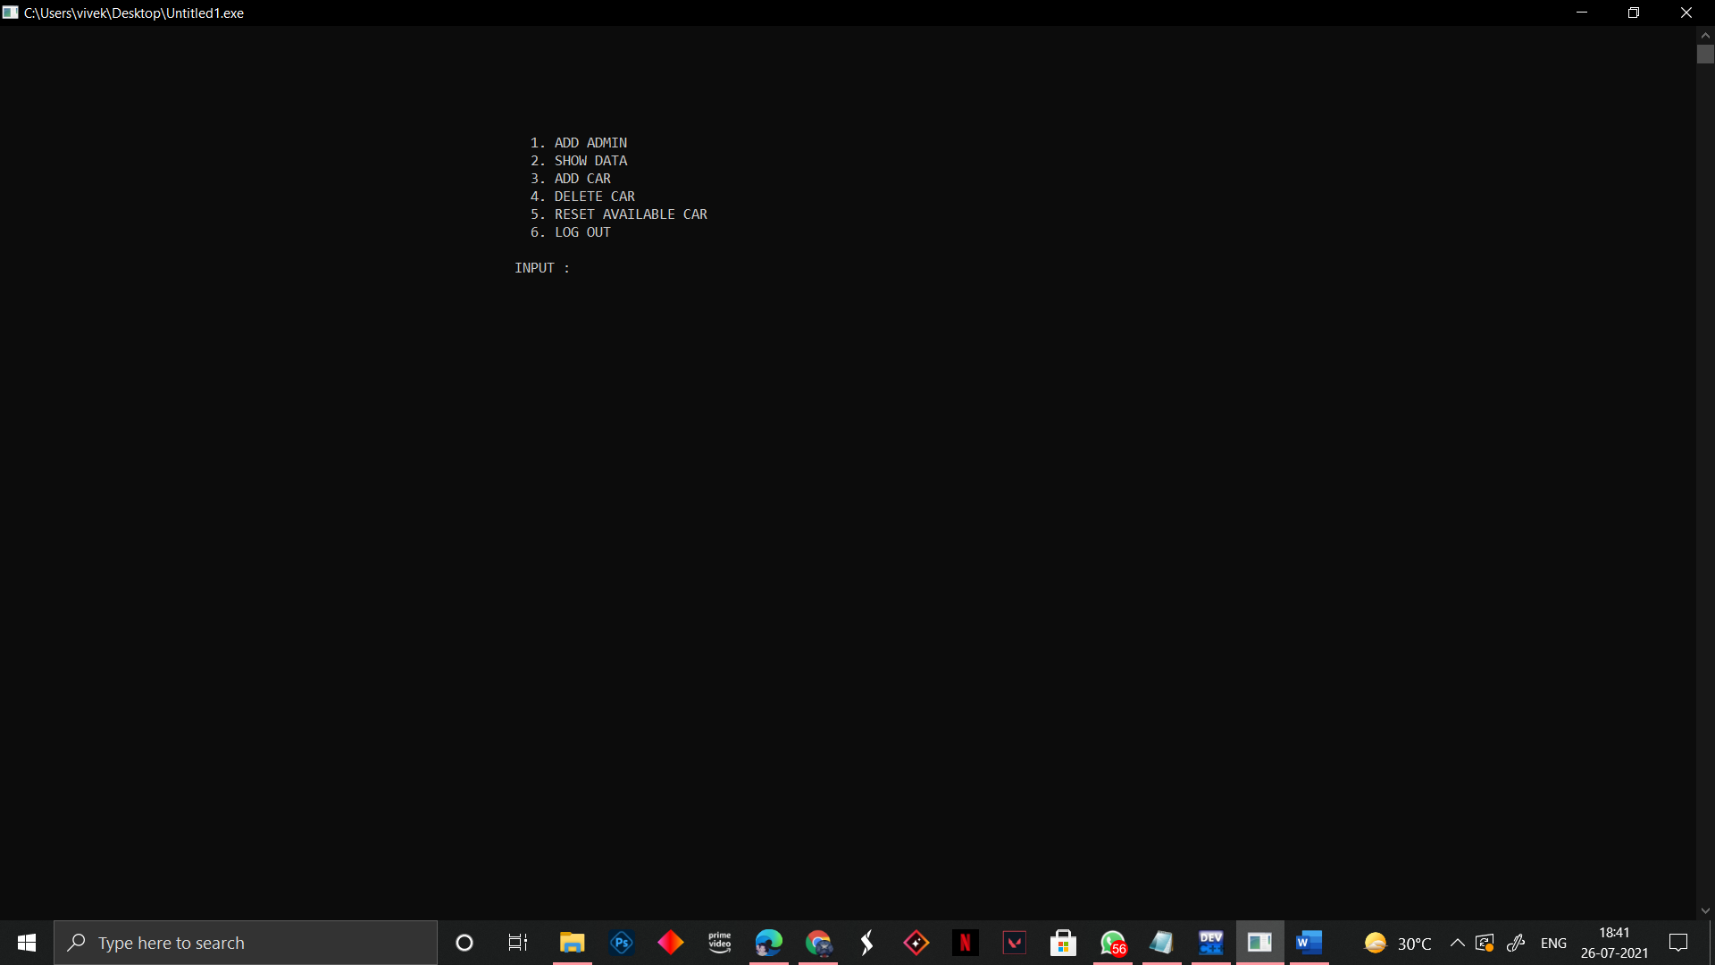

* **Add Admin :**

An Admin Can Add A New Admin Through Add Admin Option or Can Remove an Existing Admin .

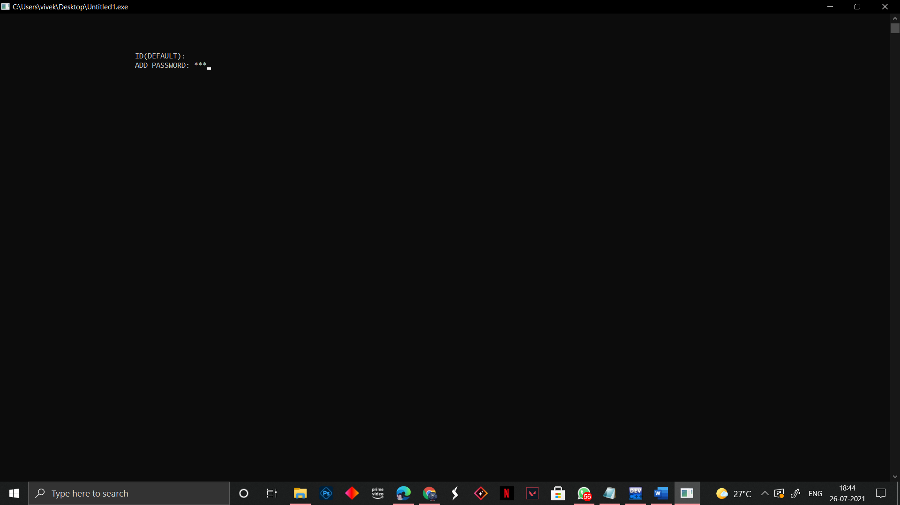

* **Show Data :**

The Admin Can Access the Car Data as Well as User Data .

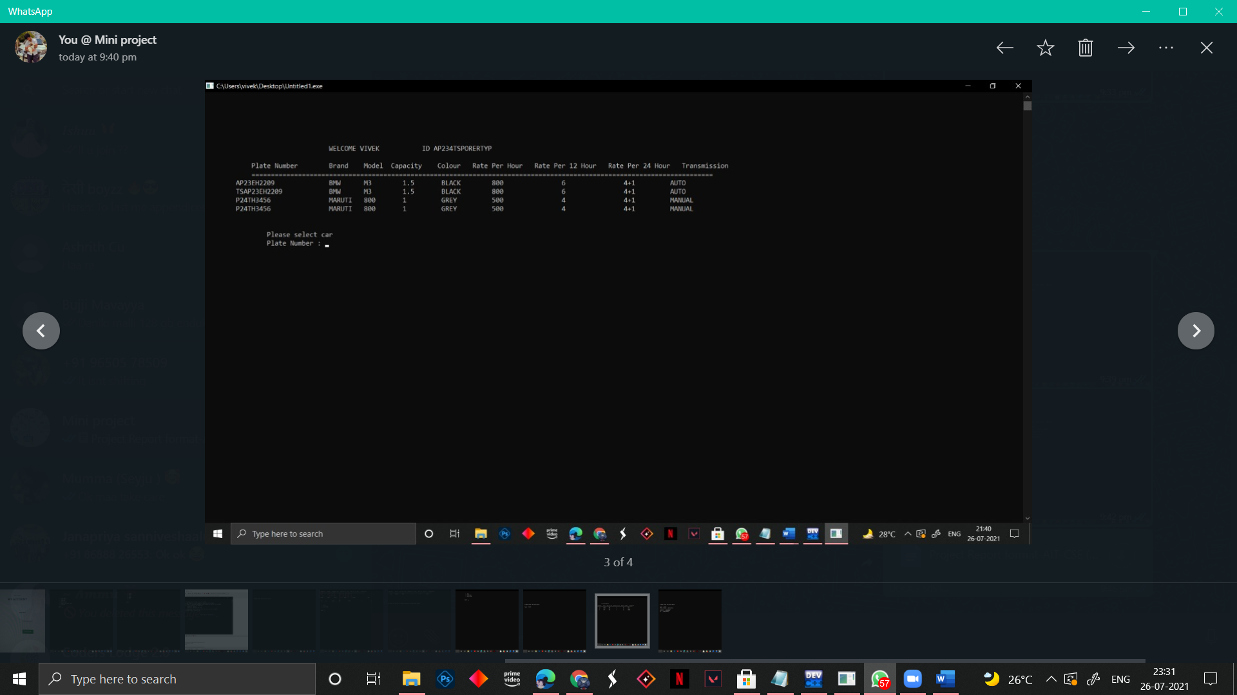

* **Add Car :**

The Admin Can Add A New Car by Adding the Following Information

1. Plate Number
2. Brand
3. Variant
4. Engine Capacity
5. Color
6. Rate Per Hour
7. Transmission
8. Seating Capacity
9. Mileage

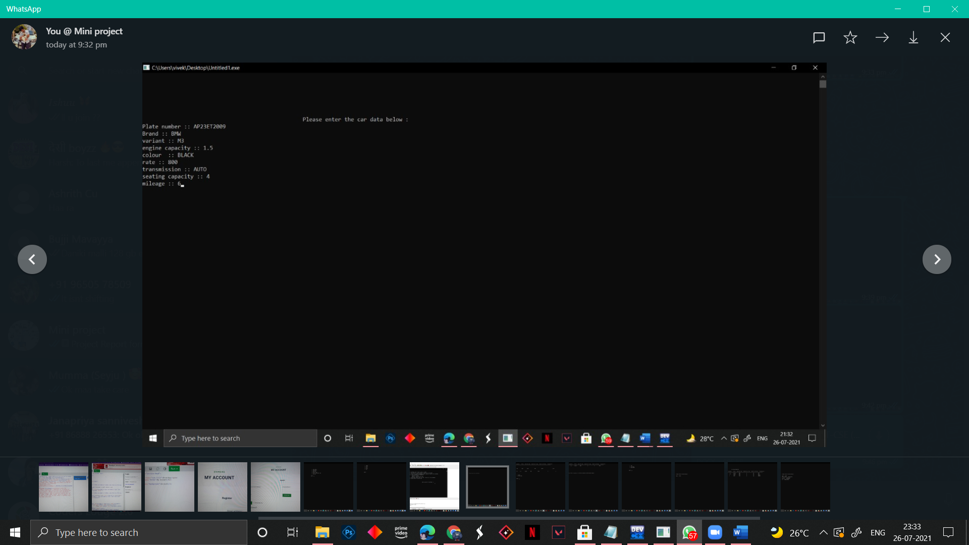

* **Delete Car :**

An Admin Can Delete A Car from The Data

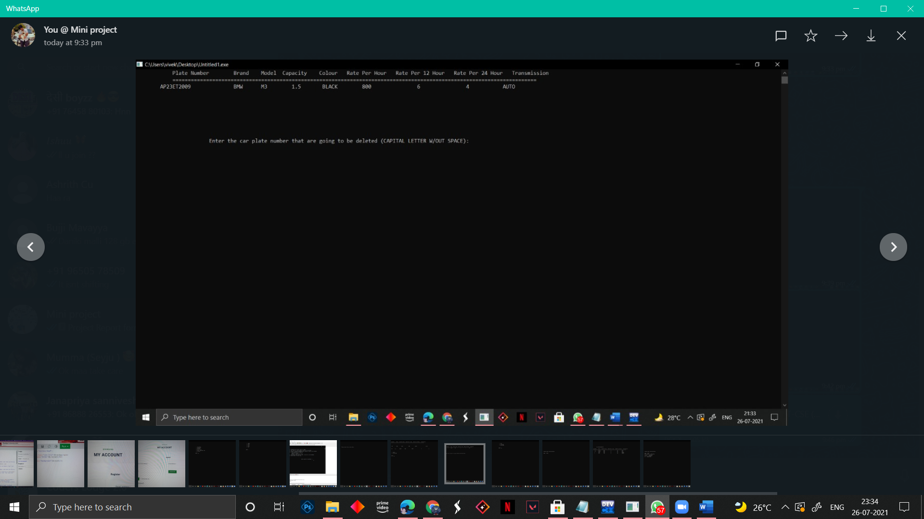

* **RESET AVAILABLE CARS :**

Admin Can Erase the Car Data Completely .

**User Interphase :**

A Person Can Login Through User Interphase to Rent A Car .

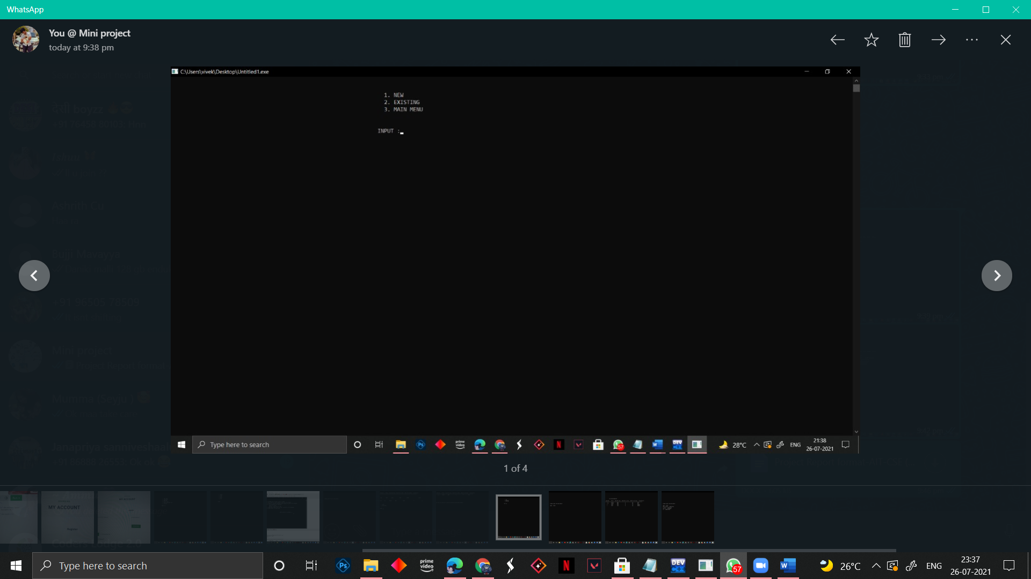

* **New User :**

The New User Should Enter the Following Details and Then Rent A Car . Vice Versa An Existing User Can Login with His Login Credentials and Book A Car .

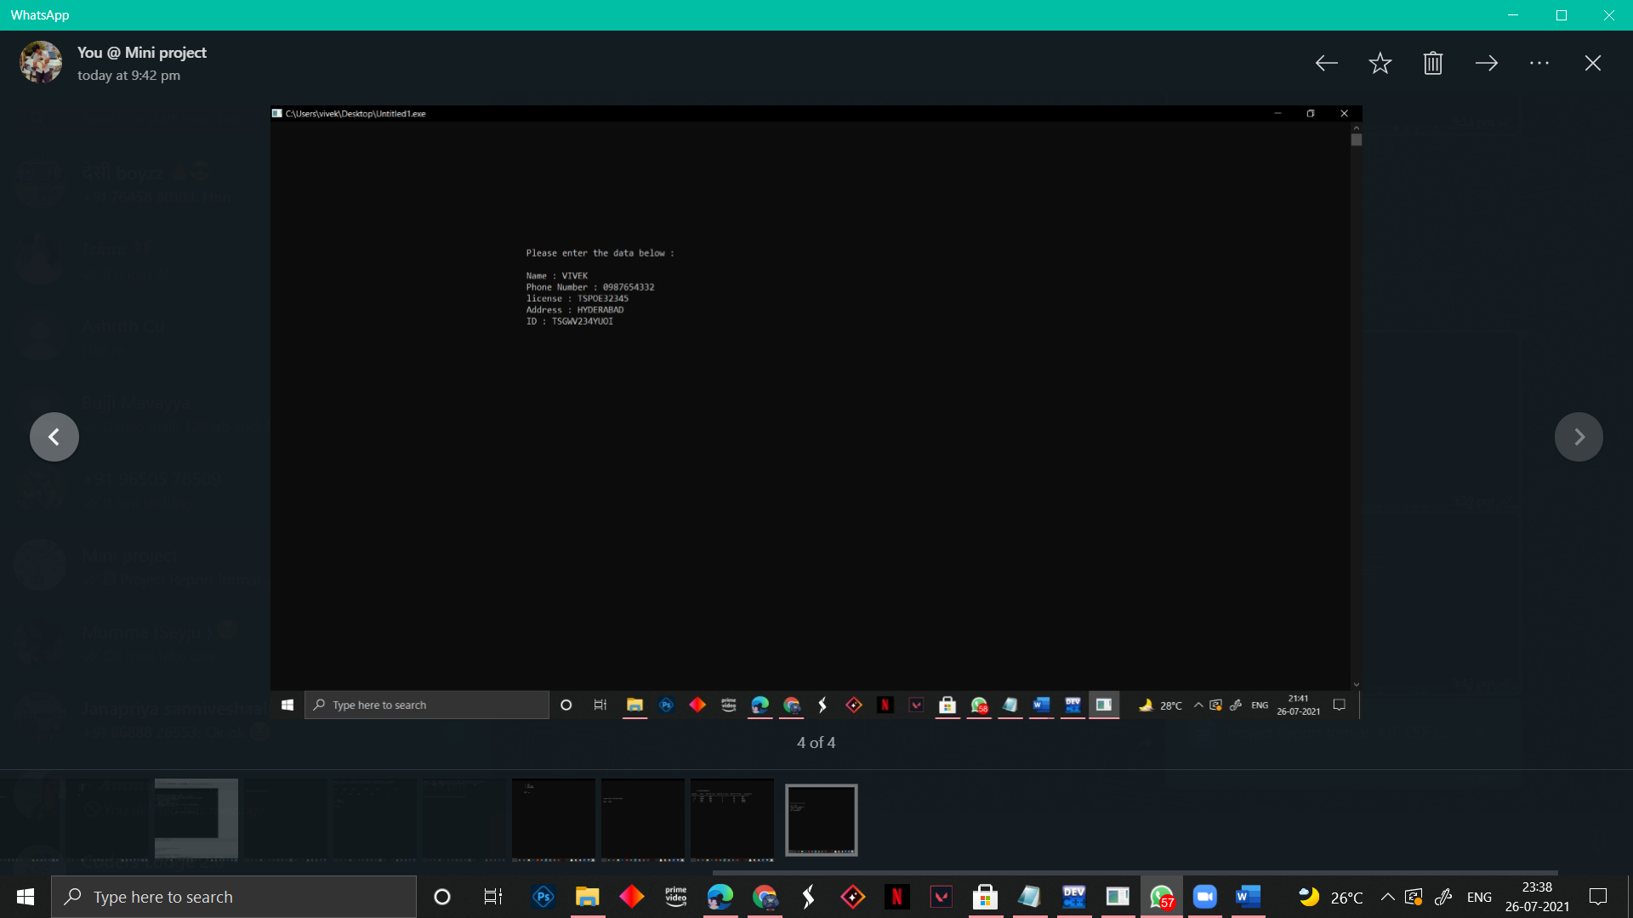

* **Renting A Car :**

The User Should Choose the Car by Selecting Car Plate Number and Then the Total Hours He Want to Rent and Then the According Payment Will Be Displayed on The Screen . So, The User Should Make the Payment and Rent A Car .

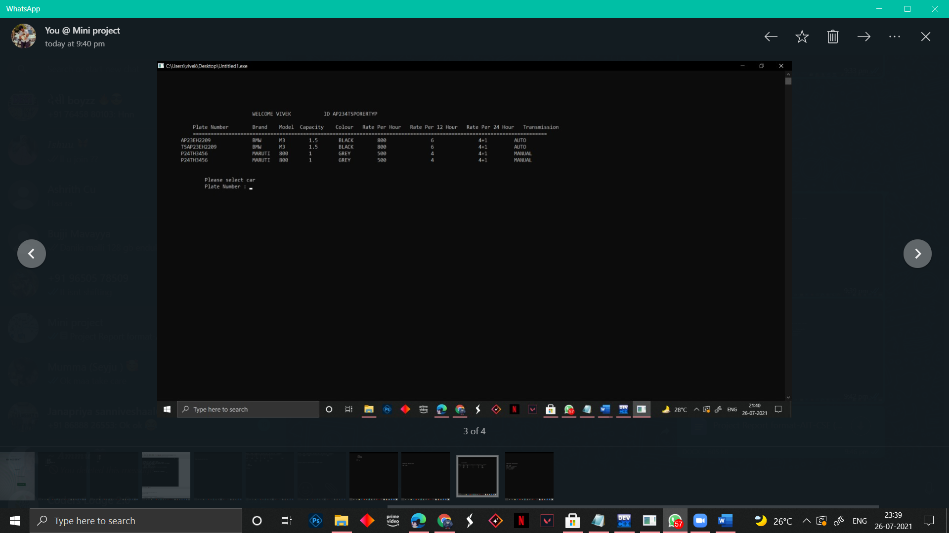

# REFERENCES

1. <https://www.geeksforgeeks.org/file-handling-c-classes/>
2. <https://www.google.com/url?sa=t&source=web&rct=j&url=http://www.cplusplus.com/forum/general/3766&ved=2ahUKEwiTnLeXyebxAhWWzzgGHXvnAI4QFnoECAMQAQ&usg=AOvVaw2je3mzj0WclDAS_qR3lWXR>
3. <https://stackoverflow.com/questions/15914839/unable-to-read-a-text-file-in-c>
4. <https://www.geeksforgeeks.org/converting-strings-numbers-cc/>
5. <https://www.cplusplus.com/reference/ctime/>
6. <https://www.geeksforgeeks.org/stringstream-c-applications/>
7. <https://www.geeksforgeeks.org/error-handling-during-file-operations-in-c-c/>
8. <https://en.cppreference.com/w/cpp/string/basic_string/to_string>
9. <https://www.geeksforgeeks.org/taking-password-as-input-in-c/>
10. [https://lucid.app/documents#/dashboard?folder_id=home](https://lucid.app/documents%23/dashboard?folder_id=home)
11. <https://www.geeksforgeeks.org/difference-getchar-getch-getc-getche/>